EXPERIMENT-2
CHARACTERISTICS STUDY OF SIDE BAND POWER AND FREQUENCIES IN AM USING MATLAB
Code:
clc; clear; close all;
%% ============================================================

% CHARACTERISTICS STUDY OF SIDEBAND POWER AND FREQUENCIES IN AM
% USING MATLAB
% ============================================================

%% 1. INITIAL PARAMETERS
Fs = 1e6; % Sampling frequency = 1 MHz T = 0.01; % Simulation time = 10 ms
t = 0:1/Fs:T-1/Fs;
% Carrier and message parameters
fc = 100e3; % Carrier frequency = 100 kHz fm = 10e3; % Message frequency = 10 kHz Ac = 1; % Carrier amplitude
Am = 1; % Message amplitude
R = 50; % Load resistance = 50 ohms

%% 2. MODULATION INDEX
mu = Am/Ac; fprintf('\n');
fprintf('====================================================\n'); fprintf(' AM SIDEBAND POWER AND FREQUENCY STUDY\n'); fprintf('====================================================\n');
fprintf('\nBasic Parameters:\n');
fprintf('Carrier Frequency = %.2f kHz\n',fc/1000);

fprintf('Message Frequency = %.2f kHz\n',fm/1000); fprintf('Carrier Amplitude = %.2f V\n',Ac); fprintf('Message Amplitude = %.2f V\n',Am); fprintf('Load Resistance = %.2f Ohm\n',R); fprintf('Modulation Index = %.2f\n',mu);

%% 3. MESSAGE SIGNAL
message = Am*cos(2*pi*fm*t);

%% 4. CARRIER SIGNAL
carrier = Ac*cos(2*pi*fc*t);

%% 5. AM SIGNAL
AM_signal = Ac*(1 + mu*cos(2*pi*fm*t)) * cos(2*pi*fc*t);
%% ============================================================

% 6. TIME DOMAIN PLOTS
% ============================================================
% Message signal figure;
plot(t*1000,message,'LineWidth',1.2); xlabel('Time (ms)');
ylabel('Amplitude (V)'); title('Message Signal'); grid on;
xlim([0 1]);
% Carrier signal figure;
plot(t*1000,carrier,'LineWidth',1); xlabel('Time (ms)');
ylabel('Amplitude (V)'); title('Carrier Signal'); grid on;

xlim([0 0.2]);
% AM signal figure;
plot(t*1000,AM_signal,'LineWidth',1); xlabel('Time (ms)');
ylabel('Amplitude (V)');
title('Amplitude Modulated (AM) Signal'); grid on;
xlim([0 1]);
%% ============================================================

% 7. AM SPECTRUM
% ============================================================
N = length(AM_signal); AM_fft = fft(AM_signal);
AM_fft_shifted = fftshift(AM_fft); f = (-N/2:N/2-1)*(Fs/N);
AM_magnitude = abs(AM_fft_shifted)/N; figure; plot(f/1000,AM_magnitude,'LineWidth',1.2); xlabel('Frequency (kHz)'); ylabel('Magnitude');
title('AM Frequency Spectrum'); grid on;
xlim([70 130]);
%% ============================================================

% 8. FIND USB AND LSB FREQUENCIES
% ============================================================
f_USB = fc + fm; f_LSB = fc - fm;

fprintf('\n');
fprintf('Sideband Frequencies:\n');
fprintf('LSB Frequency = %.2f kHz\n',f_LSB/1000); fprintf('Carrier Frequency = %.2f kHz\n',fc/1000); fprintf('USB Frequency = %.2f kHz\n',f_USB/1000);
%% ============================================================

% 9. BANDWIDTH
% ============================================================
BW_AM = 2*fm; fprintf('\n');
fprintf('AM Bandwidth:\n');
fprintf('BW = 2fm = %.2f kHz\n',BW_AM/1000);
%% ============================================================

% 10. CARRIER POWER
% ============================================================
Pc = Ac^2/(2*R); fprintf('\n'); fprintf('Carrier Power:\n');
fprintf('Pc = %.6f W\n',Pc);
%% ============================================================
% 11. SIDEband POWER
% ============================================================
P_USB = (mu^2 * Pc)/4; P_LSB = (mu^2 * Pc)/4; P_SB_total = P_USB + P_LSB;
%% ============================================================

% 12. TOTAL AM POWER
% ============================================================

P_total = Pc + P_SB_total;
%% ============================================================

% 13. POWER EFFICIENCY
% ============================================================
efficiency = (P_SB_total/P_total)*100;
%% ============================================================

% 14. DISPLAY POWER RESULTS
% ============================================================
fprintf('\n');
fprintf('Power Calculations:\n'); fprintf('Carrier Power = %.6f W\n',Pc);
fprintf('USB Power = %.6f W\n',P_USB); fprintf('LSB Power = %.6f W\n',P_LSB); fprintf('Total Sideband Power = %.6f W\n',P_SB_total); fprintf('Total AM Power = %.6f W\n',P_total); fprintf('Transmission Efficiency = %.2f %%\n',efficiency);
%% ============================================================

% 15. MODULATION INDEX STUDY
% ============================================================
mu_values = 0.1:0.1:1.0;
P_USB_values = zeros(size(mu_values)); P_LSB_values = zeros(size(mu_values)); P_SB_values = zeros(size(mu_values)); P_total_values = zeros(size(mu_values)); Efficiency_values = zeros(size(mu_values)); for k = 1:length(mu_values)
m_index = mu_values(k); P_USB_values(k) = ... (m_index^2 * Pc)/4; P_LSB_values(k) = ... (m_index^2 * Pc)/4;

P_SB_values(k) = ... P_USB_values(k) + P_LSB_values(k); P_total_values(k) = ...
Pc + P_SB_values(k); Efficiency_values(k) = ... (P_SB_values(k)/P_total_values(k))*100; end
%% ============================================================

% 16. DISPLAY MODULATION INDEX TABLE
% ============================================================
fprintf('\n'); fprintf('====================================================\n'); fprintf(' POWER VS MODULATION INDEX\n'); fprintf('====================================================\n');
fprintf('\n');
fprintf(' Mu USB Power LSB Power Total SB Total AM\n'); fprintf(' \n');
for k = 1:length(mu_values)
fprintf(' %.1f %.6f %.6f %.6f %.6f\n', ... mu_values(k), ...
P_USB_values(k), ...
P_LSB_values(k), ...
P_SB_values(k), ... P_total_values(k)); end
fprintf(' \n');
%% ============================================================

% 17. USB POWER VS MODULATION INDEX
% ============================================================

figure;
plot(mu_values,P_USB_values,'o-','LineWidth',1.5); xlabel('Modulation Index (\mu)');
ylabel('USB Power (W)');
title('USB Power vs Modulation Index'); grid on;
%% ============================================================

% 18. LSB POWER VS MODULATION INDEX
% ============================================================
figure;
plot(mu_values,P_LSB_values,'s-','LineWidth',1.5); xlabel('Modulation Index (\mu)');
ylabel('LSB Power (W)');
title('LSB Power vs Modulation Index'); grid on;
%% ============================================================

% 19. TOTAL SIDEBAND POWER VS MODULATION INDEX
% ============================================================
figure;
plot(mu_values,P_SB_values,'^-','LineWidth',1.5); xlabel('Modulation Index (\mu)');
ylabel('Total Sideband Power (W)');
title('Total Sideband Power vs Modulation Index'); grid on;
%% ============================================================

% 20. TOTAL AM POWER VS MODULATION INDEX
% ============================================================
figure;

plot(mu_values,P_total_values,'o-','LineWidth',1.5); xlabel('Modulation Index (\mu)');
ylabel('Total AM Power (W)');
title('Total AM Power vs Modulation Index'); grid on;
%% ============================================================

% 21. TRANSMISSION EFFICIENCY
% ============================================================
figure;
plot(mu_values,Efficiency_values,'d-','LineWidth',1.5); xlabel('Modulation Index (\mu)');
ylabel('Efficiency (%)');
title('AM Transmission Efficiency vs Modulation Index'); grid on;
%% ============================================================

% 22. COMPARE USB AND LSB POWER
% ============================================================
figure;
plot(mu_values,P_USB_values,'o-','LineWidth',1.5); hold on;
plot(mu_values,P_LSB_values,'s-','LineWidth',1.5); xlabel('Modulation Index (\mu)');
ylabel('Power (W)');
title('USB and LSB Power Comparison'); legend('USB Power','LSB Power');
grid on;
%% ============================================================

% 23. AM SPECTRUM FOR DIFFERENT MODULATION INDICES

% ============================================================ mu_plot = [0.25 0.5 0.75 1.0];
figure;
for k = 1:length(mu_plot)

mu_temp = mu_plot(k);

AM_temp = Ac*(1 + ... mu_temp*cos(2*pi*fm*t)) ...
.* cos(2*pi*fc*t);
spectrum_temp = fftshift(fft(AM_temp));

magnitude_temp = ... abs(spectrum_temp)/N; subplot(4,1,k); plot(f/1000,magnitude_temp); xlabel('Frequency (kHz)'); ylabel('Magnitude');
title(['AM Spectrum, \mu = ', ... num2str(mu_temp)]);
grid on; xlim([70 130]);
end
%% ============================================================

% 24. ENVELOPE OF AM SIGNAL
% ============================================================
envelope_upper = Ac*(1 + mu*cos(2*pi*fm*t)); envelope_lower = -Ac*(1 + mu*cos(2*pi*fm*t)); figure;

plot(t*1000,AM_signal); hold on;
plot(t*1000,envelope_upper,'--','LineWidth',1.2); plot(t*1000,envelope_lower,'--','LineWidth',1.2); xlabel('Time (ms)');
ylabel('Amplitude (V)');
title('AM Signal and Its Envelope');
legend('AM Signal','Upper Envelope','Lower Envelope'); grid on;
xlim([0 1]);
%% ============================================================

% 25. IMPORTANT RESULTS AT 100% MODULATION
% ============================================================
mu_100 = 1;
P_USB_100 = (mu_100^2 * Pc)/4; P_LSB_100 = (mu_100^2 * Pc)/4; P_SB_100 = P_USB_100 + P_LSB_100;
P_total_100 = Pc + P_SB_100;
efficiency_100 = ... (P_SB_100/P_total_100)*100; fprintf('\n');
fprintf('====================================================\n'); fprintf(' RESULTS FOR 100%% MODULATION\n'); fprintf('====================================================\n');
fprintf('Carrier Power = %.6f W\n',Pc); fprintf('USB Power = %.6f W\n',P_USB_100); fprintf('LSB Power = %.6f W\n',P_LSB_100); fprintf('Total Sideband Power = %.6f W\n',P_SB_100); fprintf('Total AM Power = %.6f W\n',P_total_100);
fprintf('Transmission Efficiency = %.2f %%\n',efficiency_100);

fprintf('====================================================\n');
%% ============================================================

% 26. FINAL CONCLUSION
% ============================================================
fprintf('\n'); fprintf('CONCLUSION:\n');
fprintf(['1. USB frequency = fc + fm.\n']); fprintf(['2. LSB frequency = fc - fm.\n']); fprintf(['3. AM bandwidth = 2fm.\n']);
fprintf(['4. Sideband power increases with mu^2.\n']);
fprintf(['5. At 100%% modulation, total sideband power = Pc/2.\n']); fprintf(['6. At 100%% modulation, total AM power = 1.5Pc.\n']); fprintf(['7. Maximum theoretical AM efficiency = 33.33%%.\n']);
fprintf('\n====================================================\n'); fprintf(' SIMULATION COMPLETED\n'); fprintf('====================================================\n');
Output:
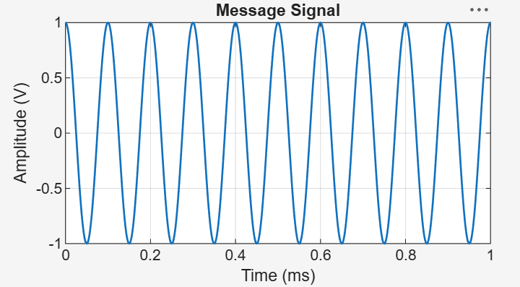
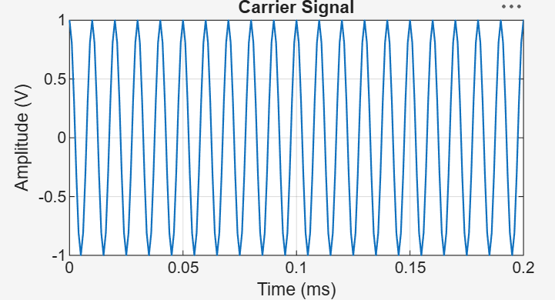
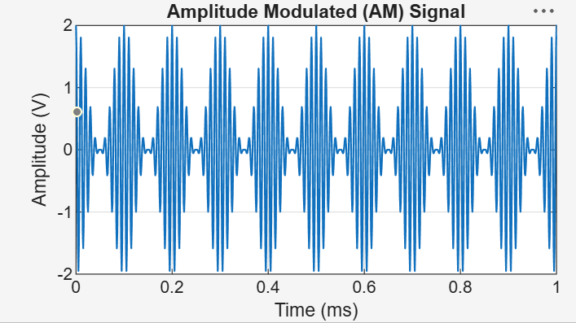
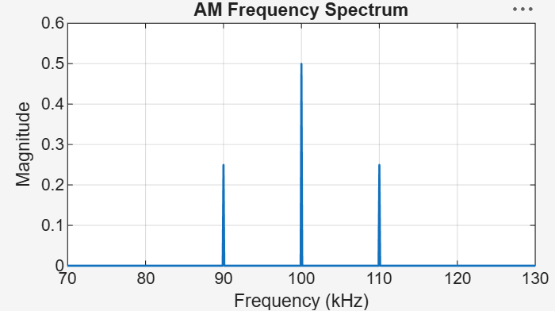

,101 USB Power vs Modulation Index
x103
LSB Power vs Modulation Index

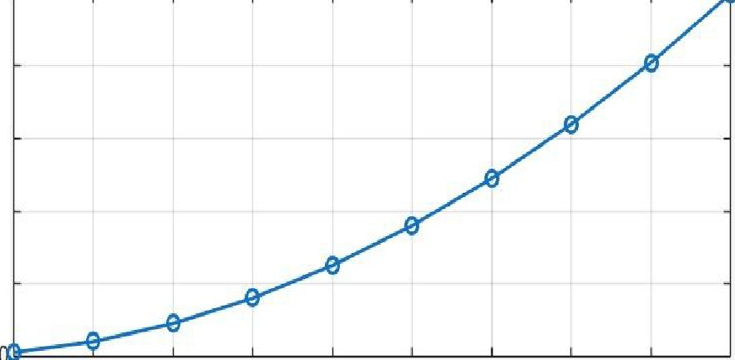
2.5�-�-�-�-�-����-� ,,)
[
a3 1.5
0
0.. 1
ID
1/)
:::J
0.5
,:
2.5�--�---�--�---�---

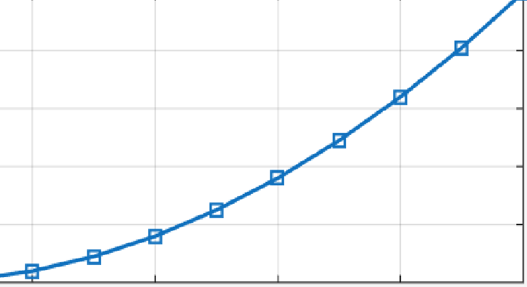
�- 2

0.1 0.2 0.3 04 0.5 0.6 0.7 0.8 0.9
Modulation Index(µ)
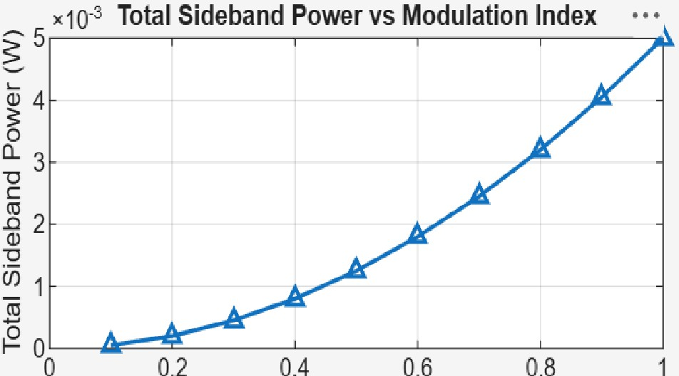
ModulationIndex(µ)
ai 1.5
�
Cl. 1
Ill
(/)
....1 0.5

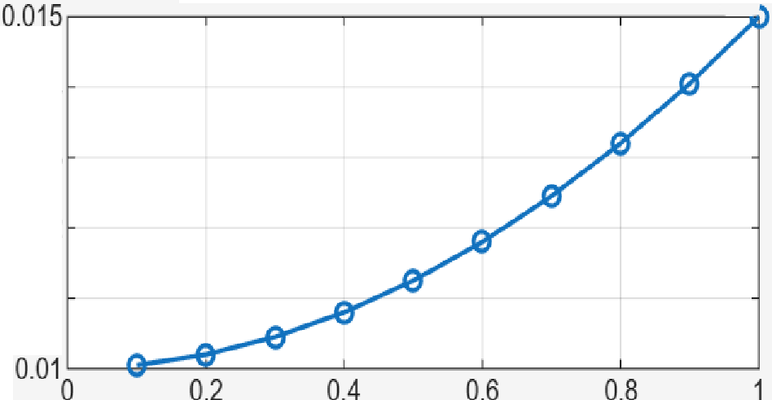
�-

0.014
0.013
0.012
0.011
L..
Q)
�
Cl.
�
(I]
0

f,=-

0.2 0.4 0.6 0.8
Modulation Index (µ)

Total AM Power vs Modulation Index

Modulation Index (µ)

AM Transmission Efficiency vs Modulation lnde>1•"
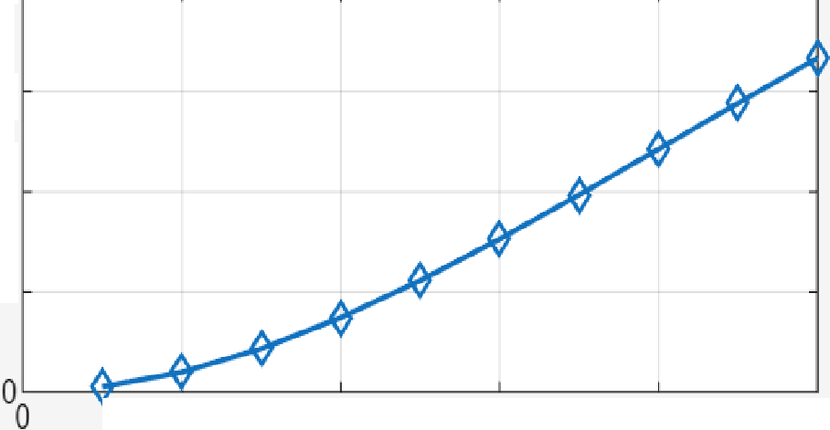
40�--�---�--�---�-- �
�30
0
>,
(I)
'ti
if
� 20
w 10
0.2
0.4
0.6
0.8
x1Q·3 USB and LSB Power Comparison
2.5�--�---�---�--� •
--&- USB Power

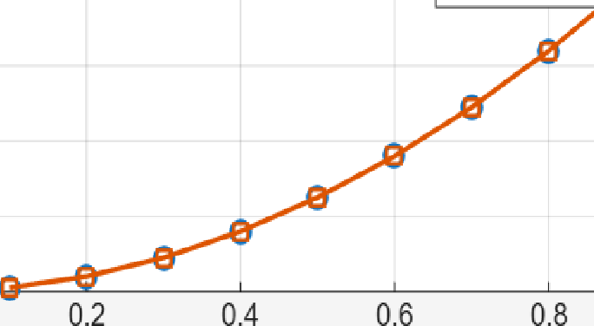
2 -a- LSB Power
�
� 1.5
ai
�
0
0...
0.5

Modulation Index (µ)
Modulation Index (µ)

0.,0

O.�O

AM Spectrum,µ= 0.25

80 90 100 110 120 130
Fre�uenc�(kHz)
AM Sp ctru , µ= 0.5 �
Q)

80 90 100 110 120 130 -0
Frequen� (kHzb �
AM Spectru , µ= .75 C.
AM Signal and Its Envelope

O.�O

O.�O
E
80 90 100 110 120 130 <(
AMFreSiueecntcr��k,Hµz-2 1

80 90 100 110 120 130
Frequency (kHz)

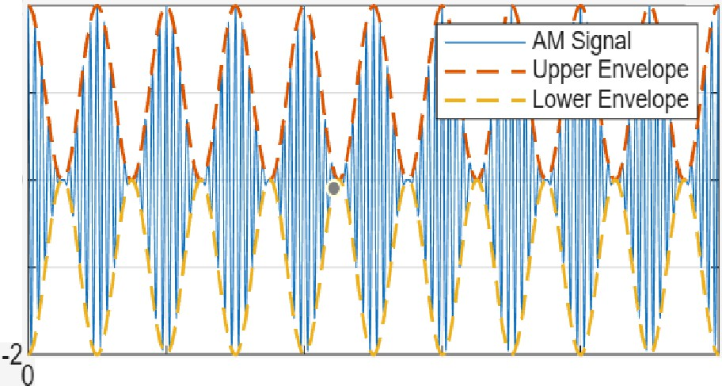
Time (ms)
2
0

-1
0.2
0.4
0.6
0.8

